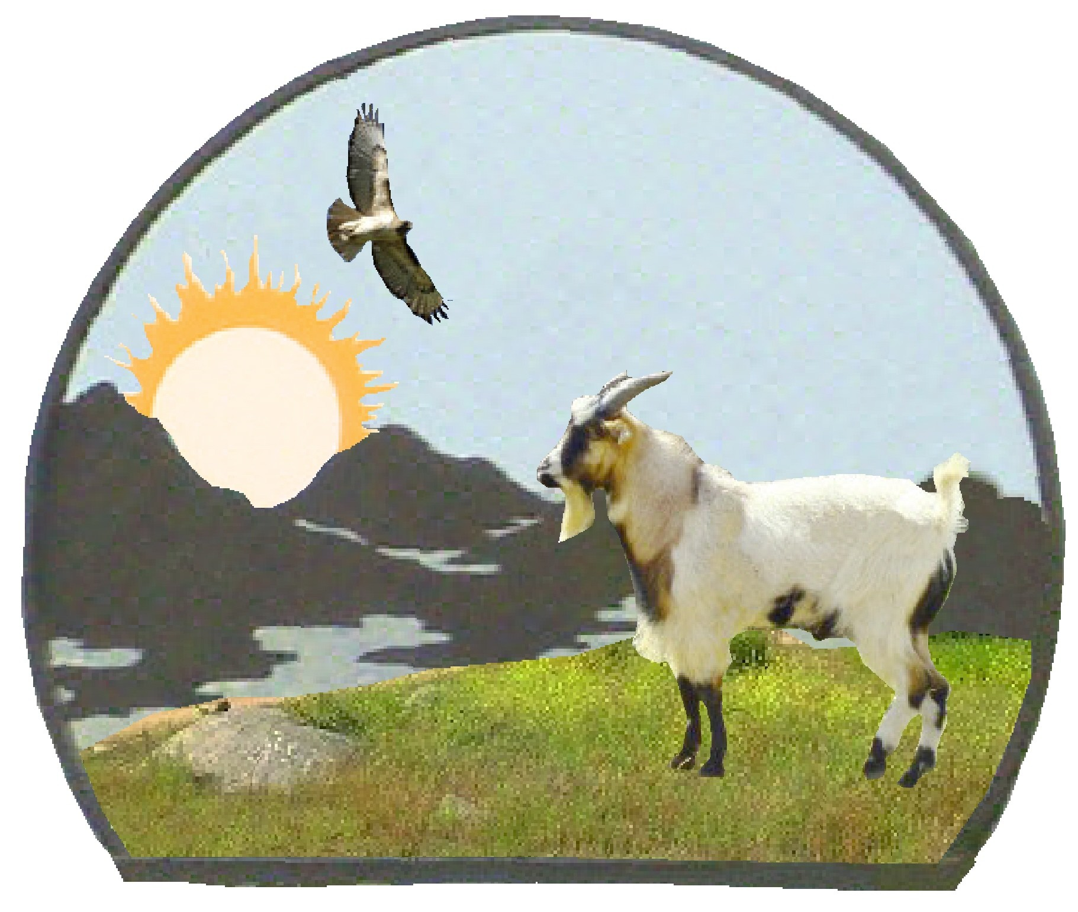 | Valley of the Sun Fainting Goat Show  November 4 - 5, 2011
ENTRY FORM (Page 1 of 2)
Entries close October 18, 2011.
The MSFGA rules govern the MSFGA shows and FGG rules govern the FGG shows.
Judges: Novemberfest Show – November 4, 2011 – TBD Fall Harvest Show – November 5, 2011 – TBD
No animal owned, co-owned or leased by the judges, or the immediate family of the judges, or purchased from the judges within six months of the show, may be exhibited in the show.

CHECK ONE OR BOTH – use additional pages if needed
Novemberfest Show  11-04-11 | Fall Harvest Show  11-05-11 | Class # | Goat Name | Goat  DOB | MSFGA Reg. #  For Silkies Only
* Copies of MSFGA certificates must be mailed with the entry forms.
Valley of the Sun Fainting Goat Show
November 4 - 5, 2011
ENTRY FORM (Page 2 of 2)
Exhibitor Information:

Name

Farm/Ranch Name

Address City State Zip

E-mail Address Telephone Number
Entry fees
$10 Wether/Doe/Buck Classes - $5 Fun classes - $0 Showmanship (pen fee still applies)
Novemberfest Show - _____ entries X $10.00 = $______ AND _______ entries X $5.00 = $_______

Fall Harvest Show - _____ entries X $10.00 = $_______ AND _______ entries X $5.00 = $_______
Pen Fee - $10 per pen:
The pen fee covers from Wednesday - Sunday and includes set-up, bedding, removal, and disassembling. Pens are 6’ x 6’.
No. of other pens needed____ X $10 = $_____

Please make checks payable to T. Teichert. Mail entry form and check: Tracy Teichert, PO Box 1211, Ramona, CA 92065.

To pay via Paypal, send money using the personal tab and chose “other”. Send money to
tracyross@ttt-ranch.com. Funds from your bank account or PayPal balance are free. There is a 2.9% + $0.30 fee when the money comes from a debit or credit card or PayPal Credit.

If you have any questions, please contact the show coordinator, Tracy Teichert, by email at
tracy@ttt-ranch.com or by phone at (760) 468-2004 (cell phone).

Statement of liability:
The Show Management will not be responsible for any loss or damage that may occur. Each exhibitor will be solely responsible for their own liabilities, if incurred, as well as damage or injury to any other person or property caused by the exhibitor or animals they exhibit.

___________________________________ _____________________
Exhibitor Signature Date

If goats are coming from a state other than California, a copy of the Health Certificate/Veterinary Inspection Report must be provided to the show secretary upon check in.

